CAD21, Digital Simulation Exercises.

NOTE; for these circuits there is no requirement for a VCC power port, BUT a GND is needed. Run only the TRANSIENT Analysis.

Digital signals can be generated by using the “CLOCK_VOLTAGE”.

To represent repeating binary numbers, simply DOUBLE the frequency from MSB to LSB.

- 2 input AND gate.

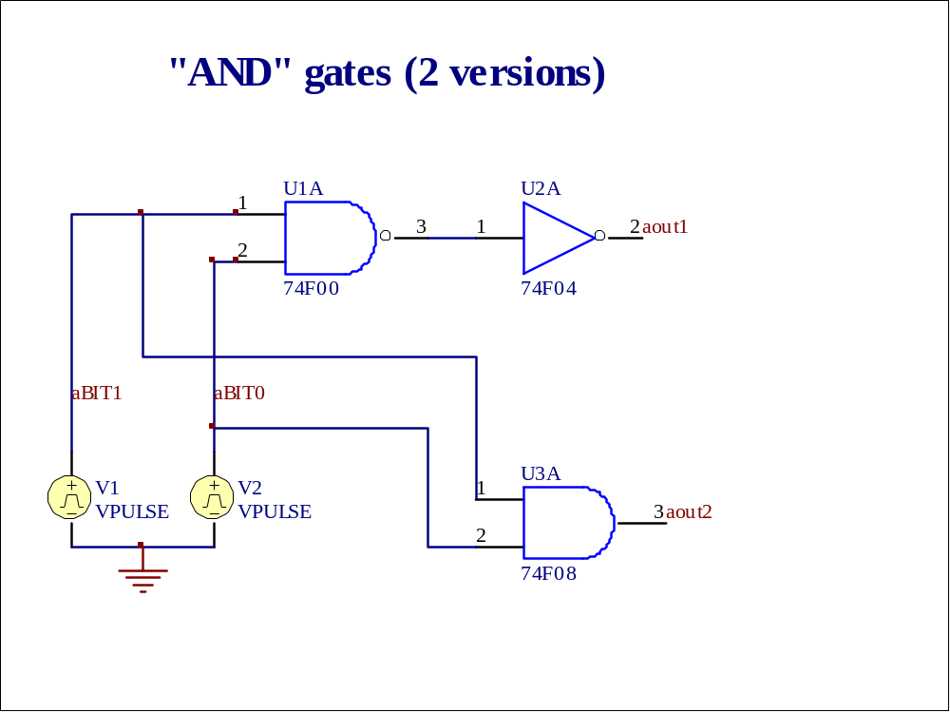

- NOR; EX-OR circuit. Again, use 2 sources with doubled frequency (eg. 10kHz and 20 kHz)

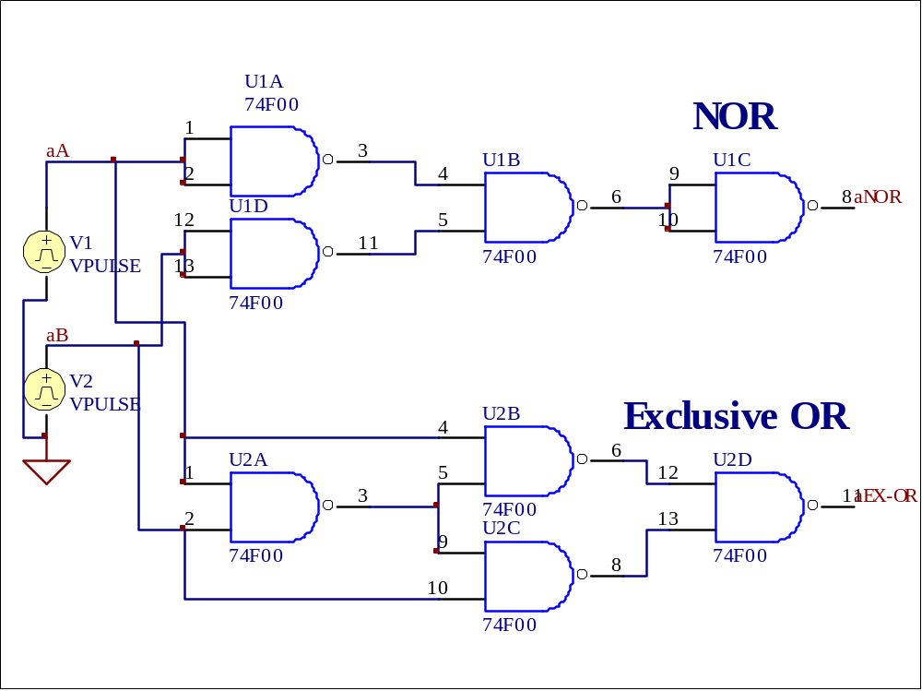

- D/A converter. Set CLOCK_VOLTAGES to frequencies appropriate to 8000 samples per second. Set TRANSIENT sweep time to clearly display full range of the output.

